**Project Design Phase-II**

**Data Flow Diagram & User Stories**

| Date | 30 August 2025 |
| --- | --- |
| Team ID | LTVIP2025TMID61036 |
| Project Name | DocSpot: Seamless Appointment Booking for Health |
| Maximum Marks | 4 Marks |

**Data Flow Diagrams:**

A Data Flow Diagram (DFD) illustrates how data moves within the **DocSpot platform**. It shows how users (patients, doctors, and admins) interact with the system, how information flows between modules, and where the data is stored.

Example: **DFD Level 0 (Industry Standard)**

* **Patient:** searches doctors, books/cancels appointments, makes payments.
* **Doctor:** manages schedule, views patient history, confirms appointments.
* **System:** handles authentication, appointment scheduling and notifications.
* **Database:** stores patient records, doctor profiles, appointment logs, and payments.
* **Admin:** manages users, verifies doctors, handles system issues.

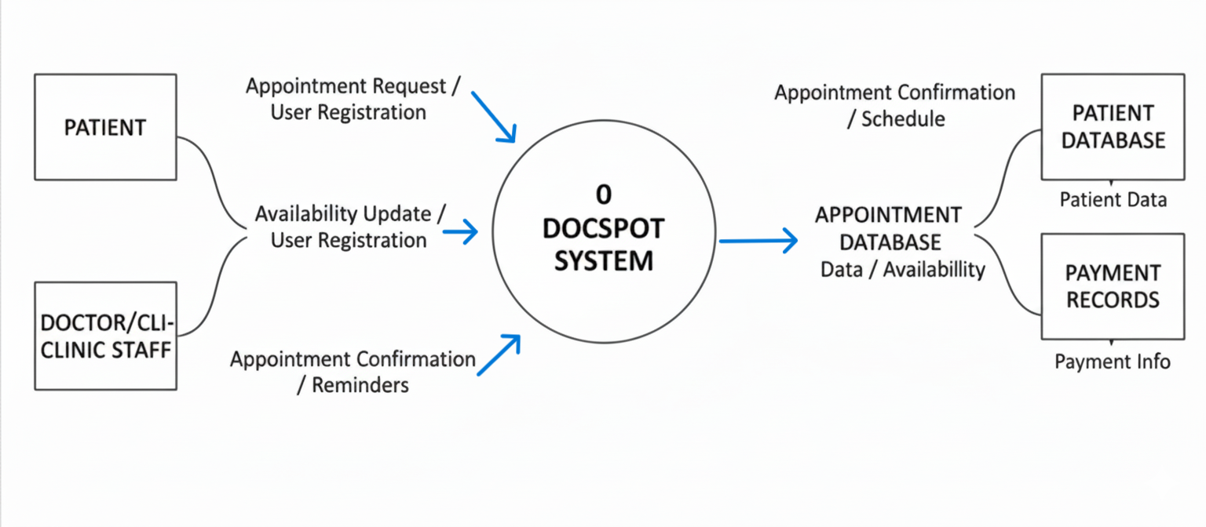

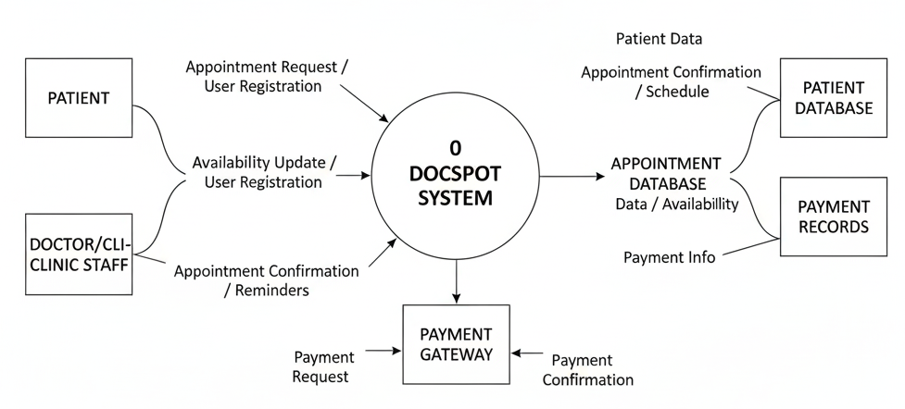

**User Stories – DocSpot**

| **User Type** | **Functional Requirement (Epic)** | **User Story / Task** | **Acceptance Criteria** | **Priority** | **Release** |
| --- | --- | --- | --- | --- | --- |
| Patient | Authentication & Profiles | As a patient, I can register, log in securely, and manage my profile. | Login works and profile changes are saved. | High | Sprint-1 |
| Doctor | Authentication & Verification | As a doctor, I can register and upload credentials for admin approval. | Credentials verified and doctor marked active. | High | Sprint-1 |
| Patient | Appointment Booking | As a patient, I can search doctors by specialty and availability. | Returns relevant doctor results. | High | Sprint-2 |
| Patient | Appointment Management | As a patient, I can book, reschedule, or cancel appointments. | Appointment status updates correctly. | High | Sprint-2 |
| Patient | Notifications | As a patient, I receive reminders/notifications for appointments. | Notification sent before scheduled time. | Medium | Sprint-3 |
| Patient | Payments | As a patient, I can make secure payments for appointments. | Payment recorded and receipt generated. | High | Sprint-3 |
| Doctor | Medical Records | As a doctor, I can view patient medical history securely. | Records accessible only to assigned doctor. | Medium | Sprint-4 |
| Patient | Feedback | As a patient, I can leave feedback/review after consultation. | Review appears on doctor profile. | Medium | Sprint-4 |
| Admin | User Moderation | As an admin, I can verify doctors and manage reported accounts. | Verification logs and admin actions saved. | High | Sprint-1 |